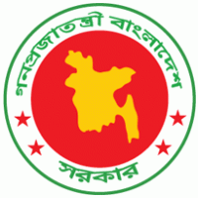
 | 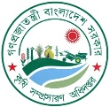 | 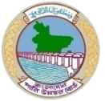
  Agro-Meteorological Information Systems Development Project
  Component-C of BWCSRP
  Department of Agricultural Extension

Special Agromet Advisory for possible Flooding

Issue Date: 21/08/2024

According to the flood forecasting and warning center of Bangladesh Water Development Board, moderate to heavy rainfall is expected in the north-eastern region of the country and adjacent upstream in the next 48 hours. As a result, the water level of the main rivers of Sylhet, Sunamganj, Netrakona, Moulvibazar and Habiganj districts in the northeastern region may increase at some points. Moreover, in the next 24 hours, the water of Muhuri and Halda rivers in Feni and Chittagong districts of southeast region may flow above the danger level and the flood situation in the lower areas may remain stable and the water of Gomti river in Comilla district may flow above the danger level and flood situation may occur in the adjacent low areas.
In such circumstances, the following suggestions are given to protect the standing crops from the harmful effects of floods:
- Harvest mature vegetables quickly before flooding occurs.
- Keep the drains clean so that water does not accumulate in the paddy field.
- Arrange for elevated bunding the land
- Make arrangements to remove excess water from cropland.
- Avoid irrigation, fertilizers and pesticides.
- Arrange poles for bananas and other horticultural crops and vegetables.
- Keep livestock and poultry on high ground.
- Elevate arround the pond. If possible, surround it with netting or bamboo mats to prevent the fish from being swept away by the flood water.

(Dr. Md. Shah Kamal Khan)
Project Director
Cell no. +8801712184274
e-mail: kamalmoa@gmail.com

