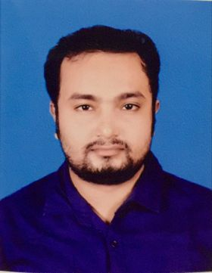
Resume
Of
Ajajmmuhammad Jefe
Contract & Address:

House # 398, Block #F, Road #07, Bashundhara R/A,
Mobile: 01783644850
E-mail:ww.jafe@gmail.com
Career Objective:
To contribute in an organization where I can instigate my knowledge and skills to add value to that organization and explore my potentials. To lead a challenge career to serve motivation and manage people with honestly.

Education Background:
Bachelor of Business Administration (BBA)
Institute : Asian University of Bangladesh
Result : 3.24.44
Major : Finance
Year of Passing : 2020

Higher Secondary Certificate (H.S.C)
Institute : Uttara Residential School and College
Group : Commerce
Result : 3.83
Year of Passing : 2016
Board : Dhaka

Secondary School Certificate (S.S.C)
Institute : Madhukhali Pilot High Scool
Group : Science
Result : 3.88
Year of Passing : 2012
Board : Dhaka

Computer knowledge:
- All M.S office & internet Browsing.
Language Proficiency:
- English : Written, Listening& spoken is good.
- Bangla : Written, Listening & Spoken is good.

Personal Details:
Name : Ajajmmuhammad Jefe
Father’s Name : Muhammad Motin Talukder
Mother’s name : Arjina Begum
Permanent Address : Alompur ,Madhukhali , Faridpur
Present Address : House # 389, Block # F, Road # 07, Bashundhara R/A
Date of Birth : 14/08/1996
Religion : Islam
Nationality : Bangladeshi
Marital status : Single
Sex : Male
Reference:
 | Name | Designation | Address | Phone number
1 | Pankoj Kumar Sarkar(Suraj) | AGM & Head of Branch | Rupali Banak Ltd Faridpur,  Corporate branch, Faridpur | 01711151893
2 | Hosneara Begum (Mila) | Principal Officer | Uttara Bank Ltd,  Motijheel, Dhaka | 01720157572

Signature

