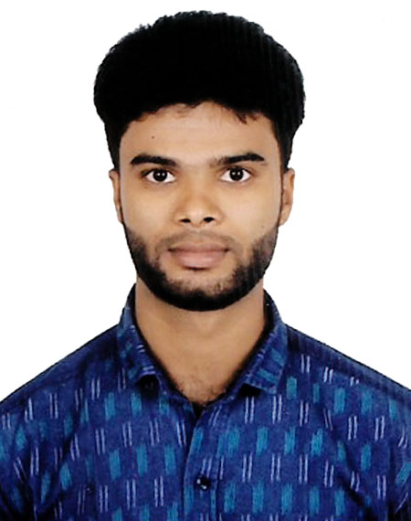CURRICULUM VITAE

OF
SOHAG MIA

[

Contact Number:01732739537
Email-:miasohag06@gmail.com

Career Objective:

To obtain a challenging position in a dynamic organization that offer development opportunity to career as well as it achieves organizational goals and objectives. I want to develop my career in a reputed company and large working group in Bangladesh where my conceptual and analytical skills can be utilized.

Educational Qualifications:

Name of Examination : Diploma in Engineering

Result : CGPA 3.71 ( OUT OF 4 )
Board : BTEB
Department : Civil
Institute : Shyamoli Ideal Polytechnic Institute

Name of Examination : S.S.C

Result : GPA 4.00
Passing Year : 2016
Board : Dhaka
Group : Business Studies
Institute : Rajarchar High School

Plumbing & Pipe Fitting
Duration | 45 Days
Institute | SIPI, Dhaka

Scaffolding (Level-1)
Institute | The City & Guilds of London Institute
Center | BKTIC, Dhaka

Auto Cad (2D & 3D)
Duration | 6 Months
Institute | BKTIC, Dhaka

Computer Basic Course:

Microsoft : Excellent in MS Word& MS Excel.
Internet : Email and Internet Browsing

Language Proficiency:

# Excellent in speaking and writing Bengali.
# Good in speaking and writing English.

Personal Information:

Full Name : Sohag Mia
Father’s Name : Shahjahan Bepari
Mother’s Name : Shahena Begum
Present address : Vill-Rajar char Gobindo Mondoler Kandi, U-P:
Sannyasirchar, P-S: Shibchar, District: Madaripur.

Permanent address : Vill-Rajar char Gobindo Mondoler Kandi, U-P:
Sannyasirchar, P-S: Shibchar, District: Madaripur.

Date of Birth : 09/03/2000
Religion : Islam
Nationality : Bangladeshi (by birth)
Sex : Male
Marital status : Unmarried
Height : 5 Fit 5 Inc
Weight : 60 kg
Blood Group : B⁺ (Positive)

Others Interest:

- Reading Books, Magazines & Newspaper.
- Traveling, Watching Movies and Sports on TV.

……………………
Sohag Mia
Date:

